Quarter 1 PPG Virtual Meeting – Spring / Summer 2026
Welcome Message
The Patient Participation Group (PPG) welcomed members to the Quarter 1 Spring / Summer 2026 meeting. The practice thanked patients for their continued support, feedback and involvement in helping improve patient care and services.
Topics of discussion
- 1.Practice Updates
- Team updates
- 3.Telephone System and Care navigation
- 4.Online consultation
- 5.Future practice developments
- 6.Vaccine Campaigns
- Friends and Family feedback
- Health Campaigns and Community News
- PPG Recruitment
- Actions and Next Steps

Practice Updates
The practice continues to provide a wide range of services including GP and nurse appointments, repeat prescription services, childhood immunisations, diabetes and asthma reviews, cervical screening, travel vaccinations and online consultation support.
Patients were encouraged to continue using online services for non-urgent queries to help improve access and reduce waiting times.
Team Updates
The practice welcomed David Boardman as the new Mental Health Practitioner. Members were informed that David will support patients with mental health and wellbeing needs, providing early support and guidance.
The practice also shared that Byron, MSK Practitioner, has now left the team. PPG members thanked Byron for his commitment and support to patients during his time at the surgery.
Telephone System and Care Navigation
The practice discussed feedback received through the Friends and Family Test regarding patients being asked the reason for their appointment request when contacting the surgery.
It was explained that the reception and administrative team have undertaken Care Navigation training to support patients in accessing the most appropriate care and services as efficiently as possible.
When patients contact the practice, staff may ask for a brief outline of the reason for the appointment request or enquiry. This information is shared confidentially with the clinical team to help prioritise patients according to clinical need and ensure they are directed to the most appropriate healthcare professional or service.
All information provided is treated sensitively, respectfully and in strict confidence. Patients are not required to provide any information they do not wish to disclose.
The practice also confirmed that telephone messages are currently being reviewed following patient feedback to improve communication and patient experience.
Online Consultations
The practice confirmed that online consultations will be moving from eConsult to Accurx during July 2026. This new system aims to provide a more streamlined and user-friendly experience for patients accessing online support and non-urgent advice.
Future Practice Developments
Due to the continued increase in patient demand, the practice is currently exploring the possibility of converting an existing office space into an additional clinical room. This would help create further appointment capacity and support improved patient access to services.
Vaccination Campaigns
The practice is continuing to promote Shingles and Pneumococcal vaccination campaigns. Eligible patients were encouraged to contact the surgery to arrange appointments.
The importance of vaccination in reducing the risks associated with pneumonia, meningitis and sepsis was discussed.
The practice discussed the ongoing COVID-19 Spring Vaccination Campaign and reminded eligible patients to book their vaccination when invited.
Patients are currently being asked to attend Rupert Street Pharmacy for their COVID-19 vaccination appointments:
Rupert Street Pharmacy
101 Rupert Street
Bolton
BL3 6QS
Patients were encouraged to contact the pharmacy directly or use the national booking system if they are eligible for the spring booster vaccination.
Friends and Family Feedback
Patient feedback remains highly positive. Members reviewed the April 2026 patient feedback word bubble, which highlighted praise for clinicians, nurses, reception staff and appointment availability.
Key themes included professionalism, compassion, efficient appointments, supportive communication and excellent patient care.
Health Campaigns and Community News
The practice shared awareness information regarding Mental Health Awareness Week 2026, World No Tobacco Day and Carers Week.
Members were also updated regarding proposed improvement plans at Royal Bolton Hospital to modernise the main entrance facilities and improve patient experience.
PPG Recruitment
The practice encouraged additional patients to join the Patient Participation Group (PPG) to help support service improvements, share ideas and strengthen communication between patients and the practice.
Patient Feedback Word Bubble – April 2026
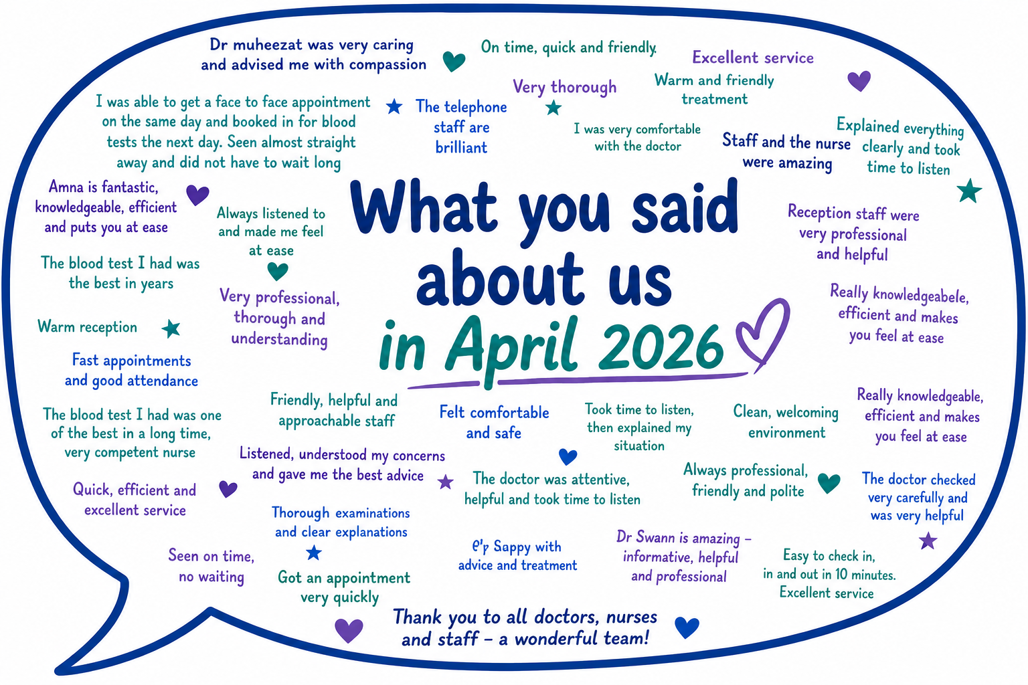
Actions and Next Steps
Continue reviewing telephone messaging and patient communication.
Support implementation of the new Accurx online consultation system in July 2026.
Continue promoting vaccination campaigns and preventative healthcare.
Explore opportunities to increase clinical capacity within the practice.
Encourage wider patient participation within the PPG group.
Contact Information
Octagon Medical Centre
Lever Chambers Centre for Health, Ashburner Street, Bolton BL1 1SQ
Telephone: 01204 969343
Website: www.boltondoctors.co.uk
Meeting closed with thanks from the Octagon Medical Centre Team

